Progress Report on Test System for Pretrained Decision Algorithms

|  |
| --- |
| Abbad Zafar  1360066  [abbad.zafar@stud.fra-uas.de](mailto:abbad.zafar@stud.fra-uas.de) |

This report details the project's current status and its unrealized future goals. I'm currently working on developing a test platform test system for trained machine learning algorithms. A Graphical User Interface (GUI) is necessary for this. A framework PyQt is utilized for the GUI. The Qt framework, a cross-platform framework used to create a variety of applications for different platforms, is the foundation of the PyQt package. A thorough set of Python bindings based on the most recent Qt application framework version 5.

On the other side, I also created a Model using CNN for testing purposes. The dataset for this model, Cats and Dogs, was provided by Microsoft, and it was used to train the model before it was stored. The results of the prediction between new random photos of cats and dogs using the saved model are shown on the GUI.

Since the last report, the project has undergone a few improvements, including the addition of the following: a) Data Folder Selection; b) Test Measure/Confusion Matrix; and c) Input Categories for which Loaded Model has been Trained.

1. **Selection of Test Data Folder**

One improvement that has been made to the project is the addition of the Test data folder. The "Test Data Folder" button now allows the user to choose the data folder. A dialog box will popup when the button is pressed, allowing the user to choose the data folder and also to create a new folder by right-clicking the mouse and lingering over the create new folder option on Windows.

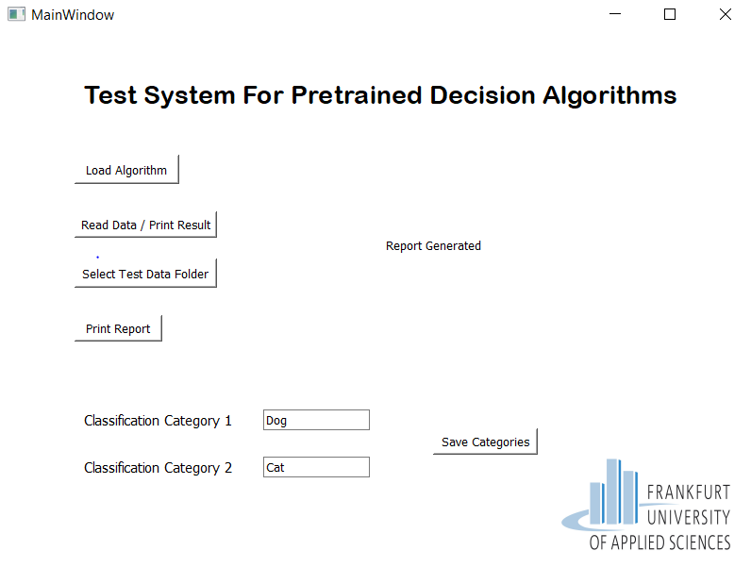

Fig 1. Data Folder Selection Button

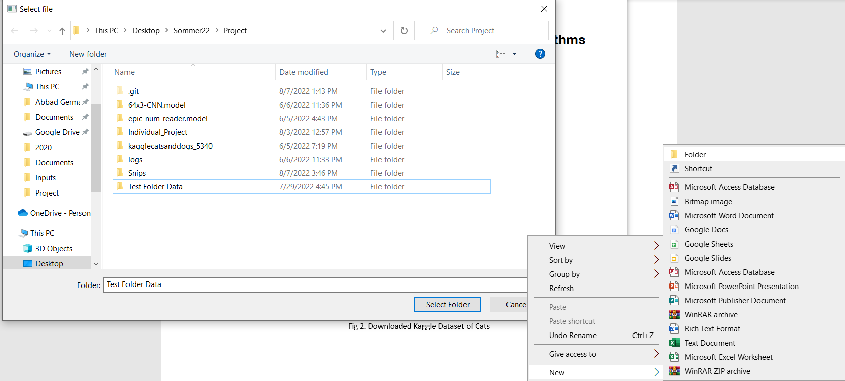

Fig 2. Selecting Data Folder and Creating New Folder Option

1. **Adding Model Categories**

Model categories are a further possibility that has been made available to users in the GUI. Now that the additional model has been trained, the user can add 2 categories. In order to save the input categories, the user can enter the name of the category in the text box and click the Save Categories button. It will be referred as Category 1 if the model predicts "0," or Category 2 if the model predicts "1." If our trained model predicts "0," it indicates the picture of a dog, and Category 1 is a dog, and if it predicts "1," it signifies the image of a cat.

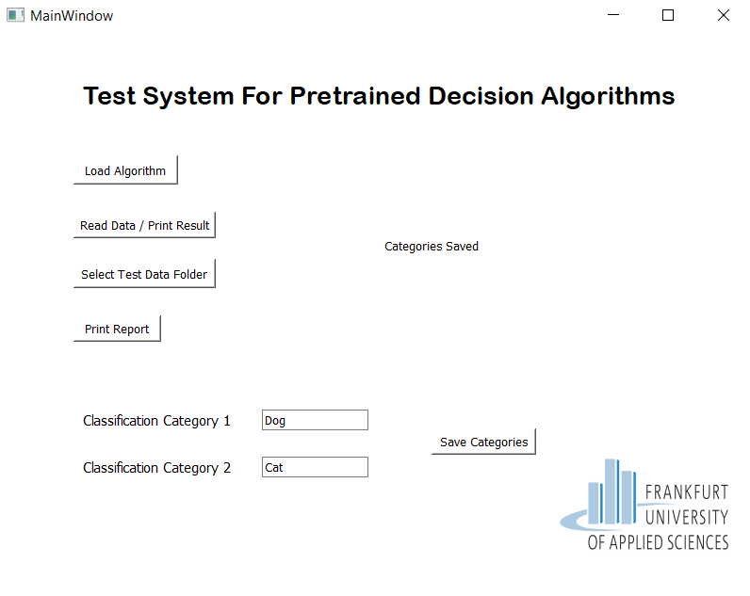

Fig 3. Adding model classification categories

1. **Confusion Matrix**

Whenever the "Read Data/Print Result" button is pressed, a confusion matrix is generated for each input that the user has chosen by selecting a data folder. Every input is collected one by one in an excel file, examined, and then an excel report with a confusion matrix displaying the TP, FP, TN, FN, TPR, FPR, TNR, FNR, F1-Score, ROC, etc. is prepared.

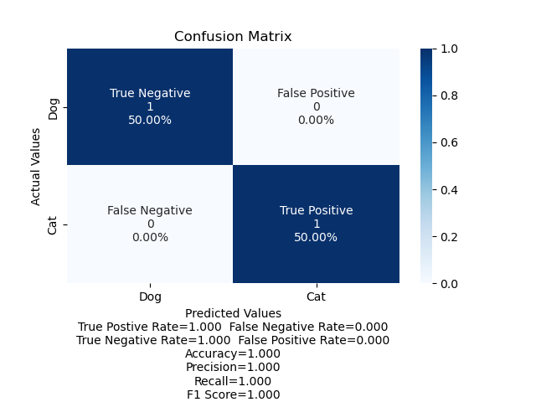

Fig 4. Generated confusion matrix

 Fig 5. Generated excel file

1. **Future Project Plan**

According to project requirements, Test measures in form of confusion matrix and excel report is being generated. The next task in the project includes providing the “Test Result” folder selection for the user, print test report function, adjustable input data structure (offset, target vector, row/column), loading MLP and SVM models.

1. **Project Demo**



Fig 6. Demo video of new features

Any feedback regarding project and project report will be highly valuable. Thank You